A Day in the Life of a Junior Security Analyst.
Screenshots of the lab environment and work provided by Try Hack Me in their module Day in the Life of a Junior Security Analyst.
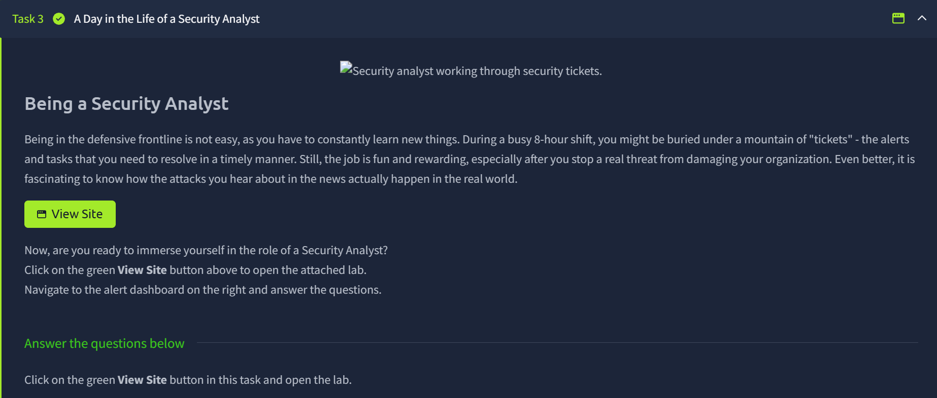
- This page appears when you click the green “View Site” button.
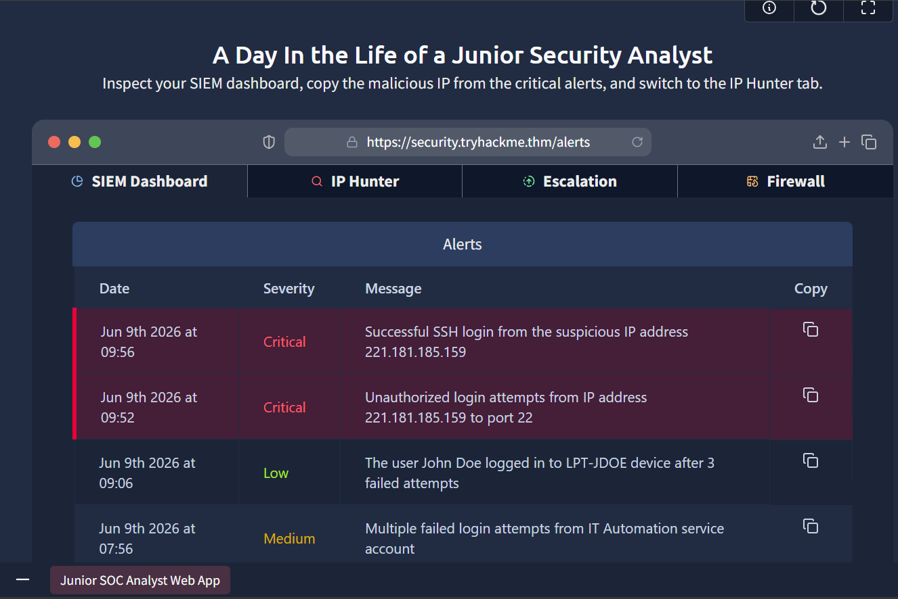
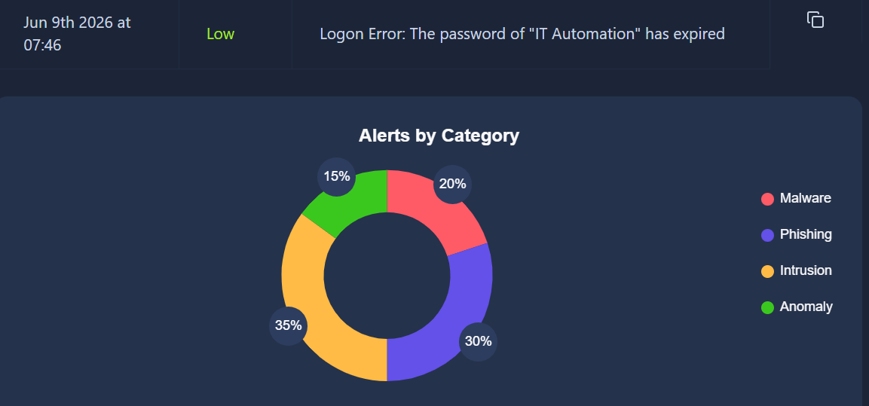
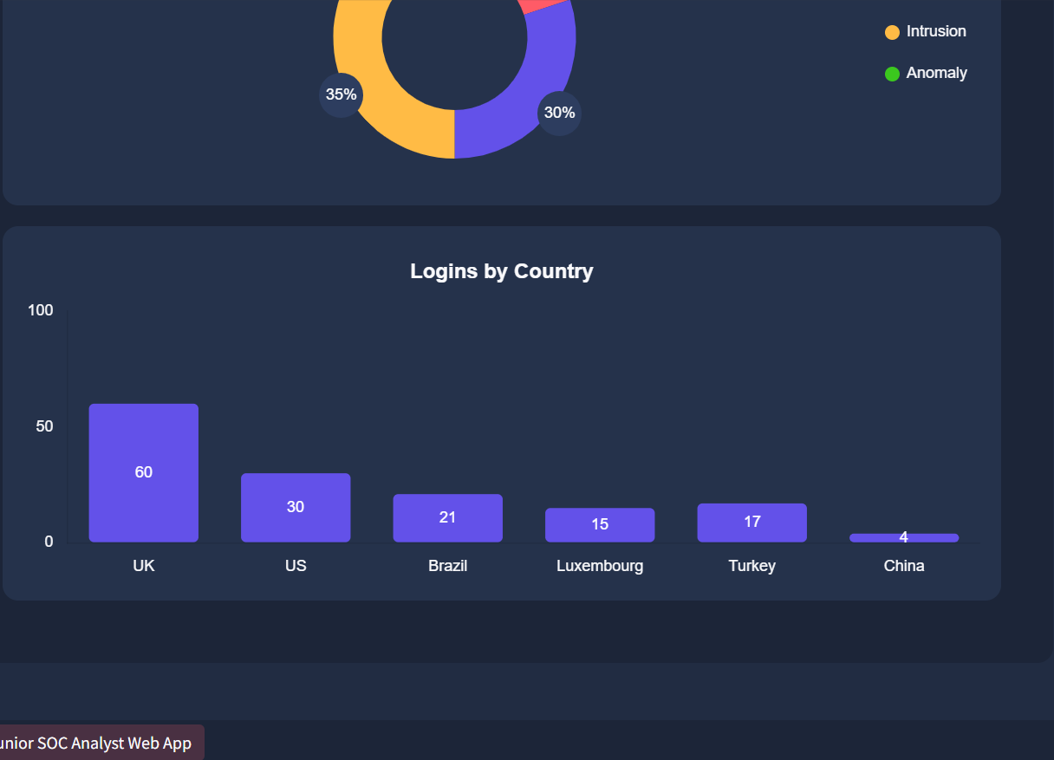
QUESTIONS
- What was the malicious IP address in the alerts?
The IP address is 221.181.185.159.
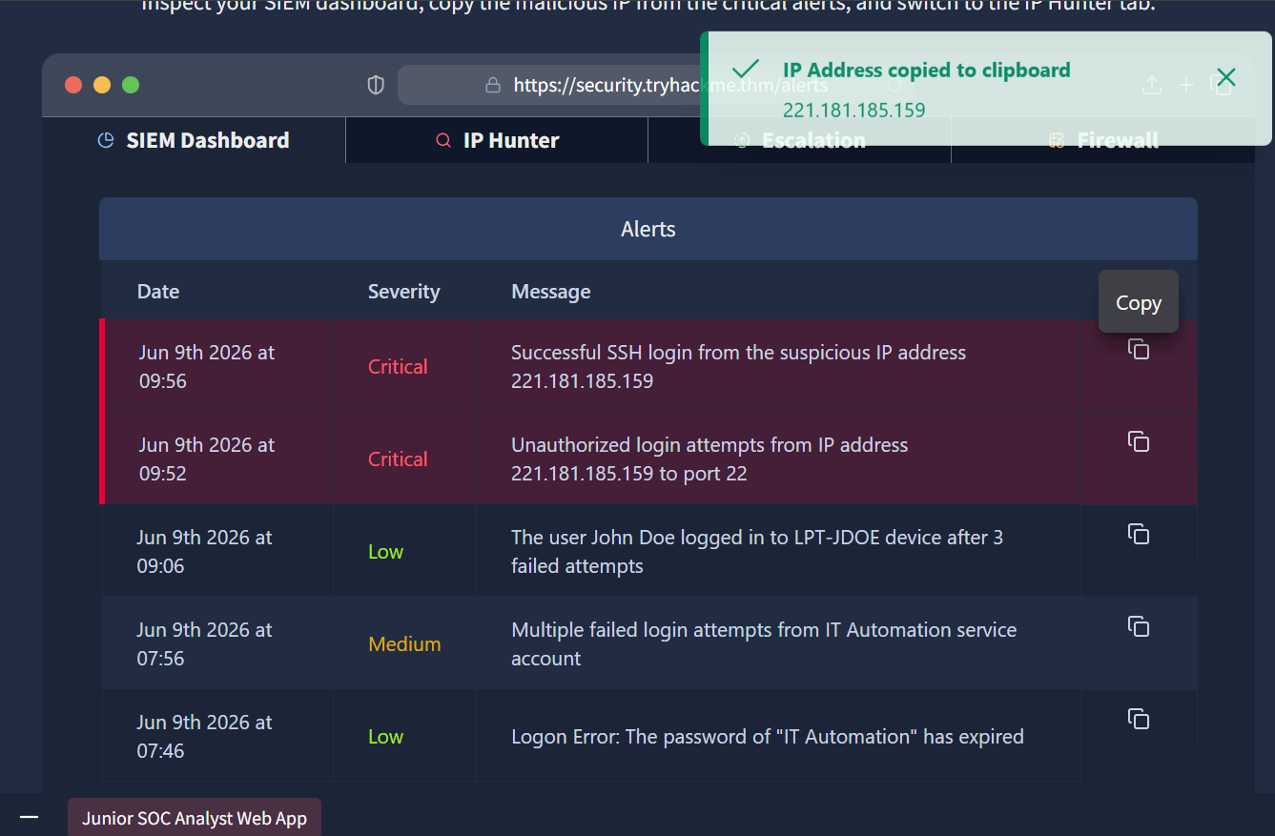
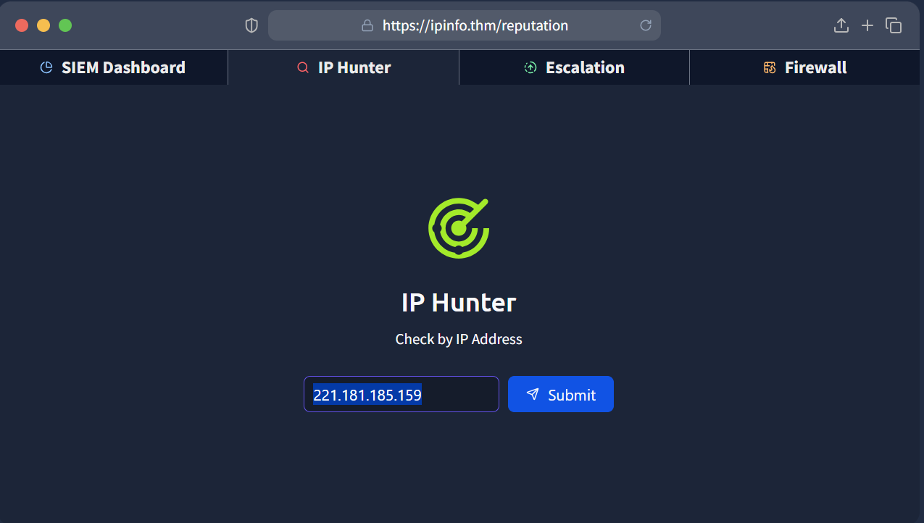
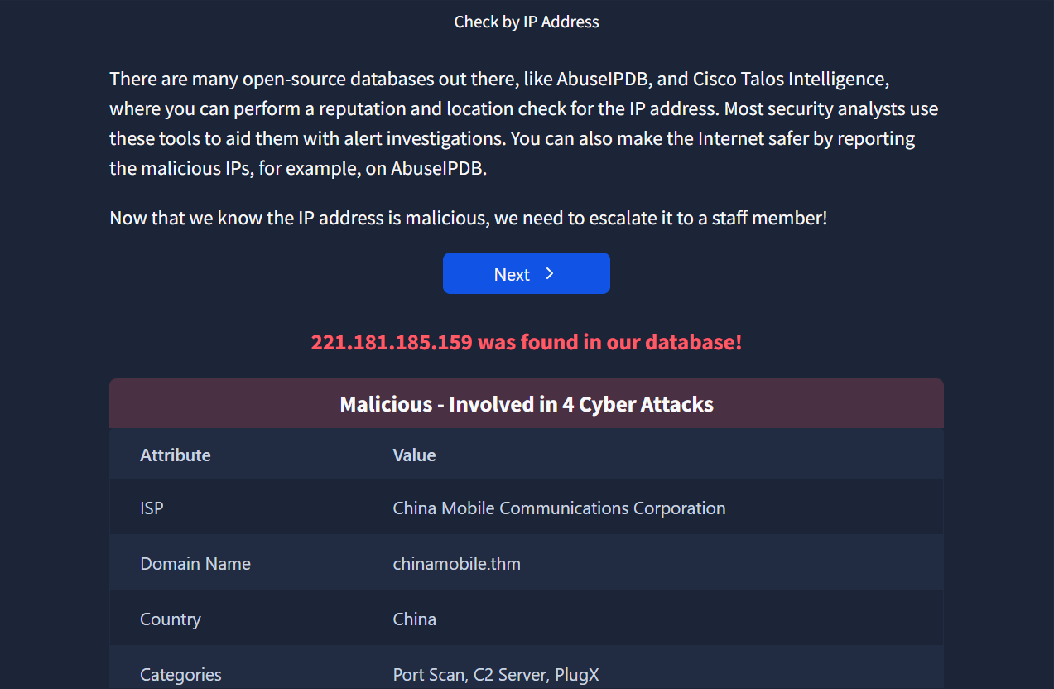

- To whom did you escalate the alert with the malicious IP?
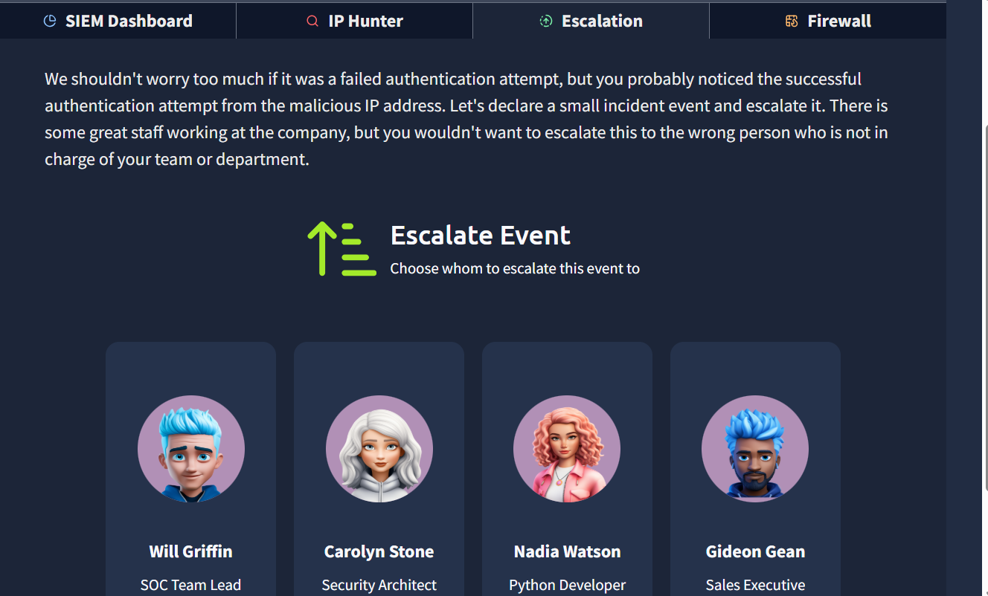
The IP was escalated to Will Griffin -SOC Team Lead.
- Carolyn Stone – Builds security tools. She does not review alerts.
- Nadia Watson – This is a Python Guru not a Cybersecurity Expert.
- Gideon Gean – He does not have the technical knowledge to triage alerts.
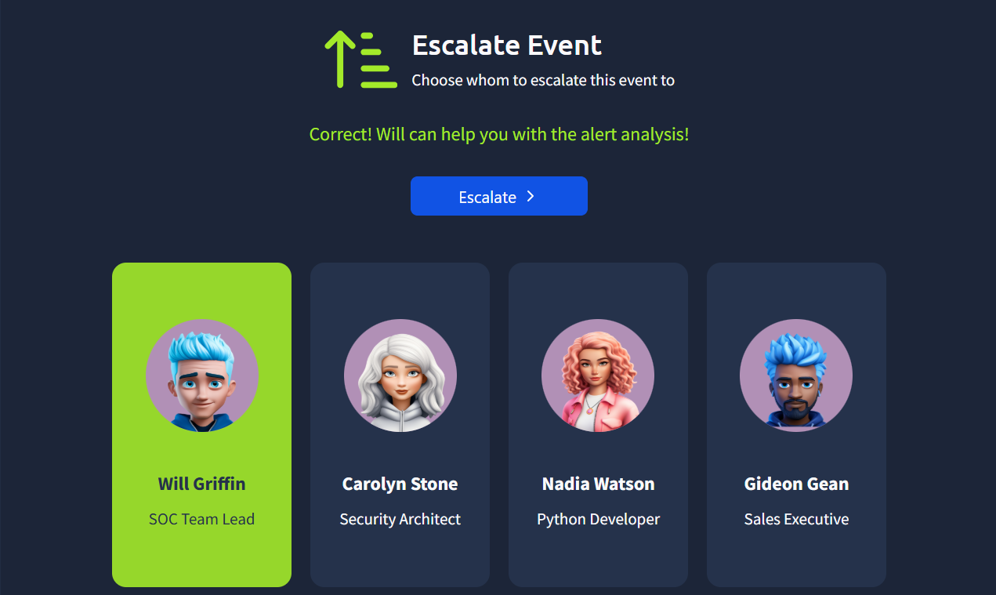

- What message did you get after blocking the IP address on the firewall?
THM{until-we-meet-again}
